A000-Afr-Nigeria-Benin-Edo peoples-Head of a queen mother *(Iyoba)*-Mid 20th c

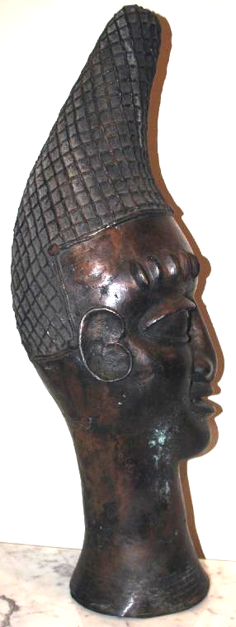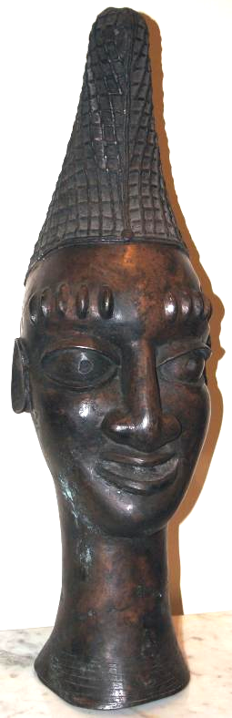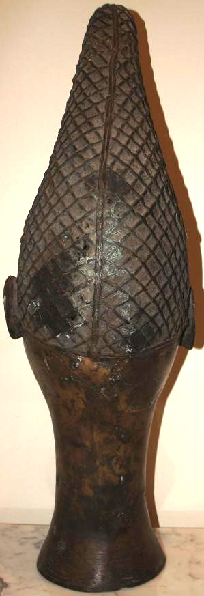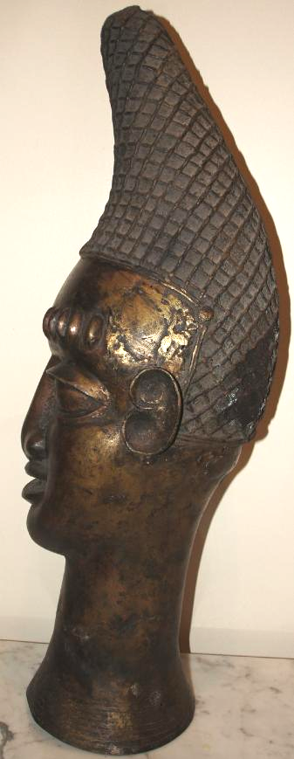

Figs. 1-4. Afr-Nigeria-Benin-Edo peoples-Head of a queen mother *(Iyoba)*-Mid 20th c

Case No.: 6

**Accession No.**

**Formal Label:** Afr-Nigeria-Benin-Edo peoples-Head of a queen mother *(Iyoba)*-Mid 20th c

**Display Description:**

This commemorative head is characteristic of the Benin lost wax court art, with finely modeled features, thin cast walls, with a cap made of red coral beads covering a distinctive beaked hairstyle that was the prerogative of queen mothers (Ben-Amos 1980, 25). This is probably an idealization of youthful feminine beauty rather than a faithful portrait (Fagg 1963, 13; Eyo and Willett 1980, 28; Dark 1973). Four supra-orbital keloids or scarifications mark the brow. Queen mother heads were taken as war booty along with great numbers of other art objects from the Benin palace treasury during the punitive expedition of February 1897. The expedition was in retaliation for the massacre of a British mission to the *Oba* of Benin the previous month. This sculpture from a prominent New York Africana collection is very similar to a piece that was acquired by the British Museum in 1897, 97.10-11.1, H. 15.5 in. (39.4 cm).

Royal ancestral altars are major shrines in the palace of the oba (king) of Benin. The current Oba, as caretaker of the shrines and chief-priest of the cult of the royal ancestors, officiates in rites invoking the protection of his ancestral fathers on behalf of his subjects. According to oral tradition, the iyoba (Iye: mother; Oba: king) of Uselu, the official title of the queen mother, was established by *Oba* Esigie (*ca*.1504–*ca*.1550) (Egharevba [1934] 1960, 28). During his reign, he had a portrait head of his mother, Idia, cast and placed in his palace to commemorate her role in the Benin-Idah war, thereby including, for the first time, queen mothers in the cult of royal ancestors.

**LC Classification:** N7397 N5

**Date or Time Horizon: m id. 20th c**

**Geographical Area: Nigeria, Bernin**

**Map:**

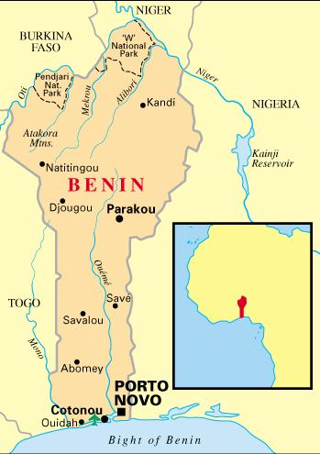



http://www.derreisefuehrer.com/a/main/8f350f44-1a25-476a-9457-1c431cc20c8b/41AF38DE-7933-11DB-9FB2-8F4527C0BFE9/4DC6B502-7933-11DB-8DAC-994FBF05B2D8.gif

**GPS coordinates:**

**Cultural Affiliation:**

**Media:** Cast copper alloy, iron inlay

**Dimensions:**

**Weight:**

**Condition: original**

**Provenance:**

**Discussion:**

**References:**

Ben Amos, Paula. 1980. *The art of Benin*. London: Thames and Hudson.

Dark, Philip J. 1973. *An introduction to Benin art and technology*. Oxford: At the Clarendon Press.

Egharevba, Jacob. [19341 1960. *A short history of Benin.* 3d ed. Ibadan, Nigeria: Ibadan University Press.

Eyo, Ekpo and Frank Willett 1980. *Treasures of ancient Nigeria*. New York: Knopf in association with Detroit Institute of Arts.

Fagg, William B. 1963. *Nigerian images: the splendor of African sculpture.* New York: Praeger.